*What is the risk:*

malicious attack, data theft, SQL injection

*Security:*

safeguarding machines from power failure or human error, design flaws.

*Privacy:*

Meta information, web use.

Bt phone hacks, as bt stays on the same line for 3 minutes after assumed hang up, hacker threat.

**Security is only as good as the weakest link**

Parts of the system

*OS*

*Networking*

*Devices*

*Physical security*

*People*

**Google this**

Bot net? Rent? For database/ bank attacks?

Anonymity to network properties: for everyone:

Hiding your meta data,

traceability:

likability

observability

Additional concepts

Authenticity

Accountability

Threat

Vulnerability

Attack

Control & defenses

**Security entails**

Identifying assets & Vulnerability

Designing counter measures

Assessing risk

**Classes of threat:**

Disclosure - snooping

Deception - spoofing modification, denial of receipt

Disruption - modification, trying passwords at scale

Usurpation -

**Classes of threat security solutions:**

Security mechanism - tools in place, detect, respond, recover

Bank machine threat. The ATM key, user trust. Shoulder surfers, security maintanance attacks with within

Week 2

Assists: money, personal details, pin numbers, bank

Threats: theft, malicious attacks, advisory.

vulnerability: theft of card, money and pin, shoulder surfing

Legal: designing counter measures, secure system

Security policy: recover and respond any stolen details money, mirror mechanism, multi-level security.

Adverse attacks: bank staff. Maintain attacks, attacks on security systems

Cash in box = rogue staff = background security checks on all staff, facial recognition, personal keycards, GPS tracking on keycards.

User trust = gangs stolen cards = policy, atm must checks at certain intervals, check additional hardware installed, mechanism, hourly checks,

Skilled hackers = ATM key = key update in encryption to prevent risk from attackers,

opportunist theirs, policy to education customers, via random theft at ATMS via, online eLearning. ATM.

**Pin**

Formalize social protocol around ATM usage

surveillances devices. Fully randomized keyboard layout

**ATM key**

needs multi person access, never hand it out. Single use key, except generation of customer pins. Cannot be labeled as a weak key

**Physical ATM**

Ripped from wall, alarm machoism, GPS tracing, self-destroying hardware, cash sprayed with ink upon theft.

**Cash vault**

Should cost more to break than value inside.

Tamper resistant audit trail. Bank managers should be put in surveillance checks.

IoT Lock:

Assets:

Adversary model: skilled hacker, script keys, anyone, anywhere. Friends & family, partners.

Week 3 Paper read through notes

ATM hacks again

* Phantom withdrawals
* Banks neglecting wrong-doing for fear of wide spread loss of trust and gain from other banks
* Banks not sharing faults, there for no research into patching, repairing and building stronger systems.
* Insider attacks
* Often bank mangers neglect to inform of mistakes for fear of losing face.

User authentication

1. Top secret
2. Secret
3. Public

Attacks

* Shoulder surfing
* Key logger (hard/software)
* Phishing
* session

Threat model

* Friends and family
* Cyber hackers
* Opportunistic people

Server-side password attack models

* Using MD5 hash generator (not encryption, obscuring)
* To make it harder, add hash and salt (salt is randomly generated when password is set) this goes in front of the password, the user does not need to know this.

Biometric security (iris, thumb print)

* Comparison computer errors
* Systems incorrectly accepts or false accepts
* Facial recognition fails 20%
* Criminals stealing cars with owners and or thumb.
* Gelatine liquid to recreate finger prints
* **Biometric is not private it is public**

Password policy

* Don’t use same passwords, or words from dictionary

Google birthday paradox

Week 5

* Subsequent data is encrypted under the session key which is discarded at the end of the session
* Participants use Diffie-Hellman key-exchange (with digital signature) to obtain a shared session key

Key exchanges must have a time stamp, or a hacker could impersonate the user A when talking to user B









**What is the hash function:**

Very hard to reverse, designed to be a one-way function.

No collisions, collision resistance

**Symmetric key & asymmetric key**

Symmetric key, using the same key to open something, using a different key open is asymmetric key.



Review of everything learned so far

**Byte & Bit:**

**A measure of how much and fast your information is being transferred**

8 bytes is a bit, 0 and 1’s

One bit of information = 0/1 = one bit, 0 or 1

Two bit of information = 00/11 = two bits

Eight bit = 1 byte

1024 = 1 kilo

This is how data is stored, when this information is being transferred on the web it becomes, bit rate.

**Hash algorithm**



Public and Private keys also use asymmetric keys = public keys everyone has, then a private key is needed to decrypt the data from the public key. For example, alice sends out her public key to 10 people, 10 people send her emails using the public key, the emails can only be opened by alice as she needs the private in conjunction with her public key to decrypt the email.

In order to obtain integrity, you can also sign (which means to hash the email before sending) this ensures no one has changed the text in the email.



**HMAC:**



In [cryptography](https://en.wikipedia.org/wiki/Cryptography/key_length), an HMAC(sometimes expanded as either keyed-hash message authentication code or hash-based message authentication code) is a specific type of [message authentication code](https://en.wikipedia.org/wiki/Message_authentication_code)(MAC) involving a [cryptographic hash function](https://en.wikipedia.org/wiki/Cryptographic_hash_function) and a secret [cryptographic key](https://en.wikipedia.org/wiki/Cryptographic_key)

ECB Mode **What is a block cipher:**

In cryptography, a block cipher mode of operation is an algorithm that uses a [block cipher](https://en.wikipedia.org/wiki/Block_cipher) to provide an [information service](https://en.wikipedia.org/wiki/Information_security) such as [confidentiality](https://en.wikipedia.org/wiki/Confidentiality) or [authenticity](https://en.wikipedia.org/wiki/Authentication).[[1]](https://en.wikipedia.org/wiki/Block_cipher_mode_of_operation#cite_note-NIST-BLOCK-CIPHER-MODES-1) A block cipher by itself is only suitable for the secure cryptographic transformation (encryption or decryption) of one fixed-length group of [bits](https://en.wikipedia.org/wiki/Bit) called a [block](https://en.wikipedia.org/wiki/Block_(data_storage)).



**Stream cipher**





**Normal web browsing** 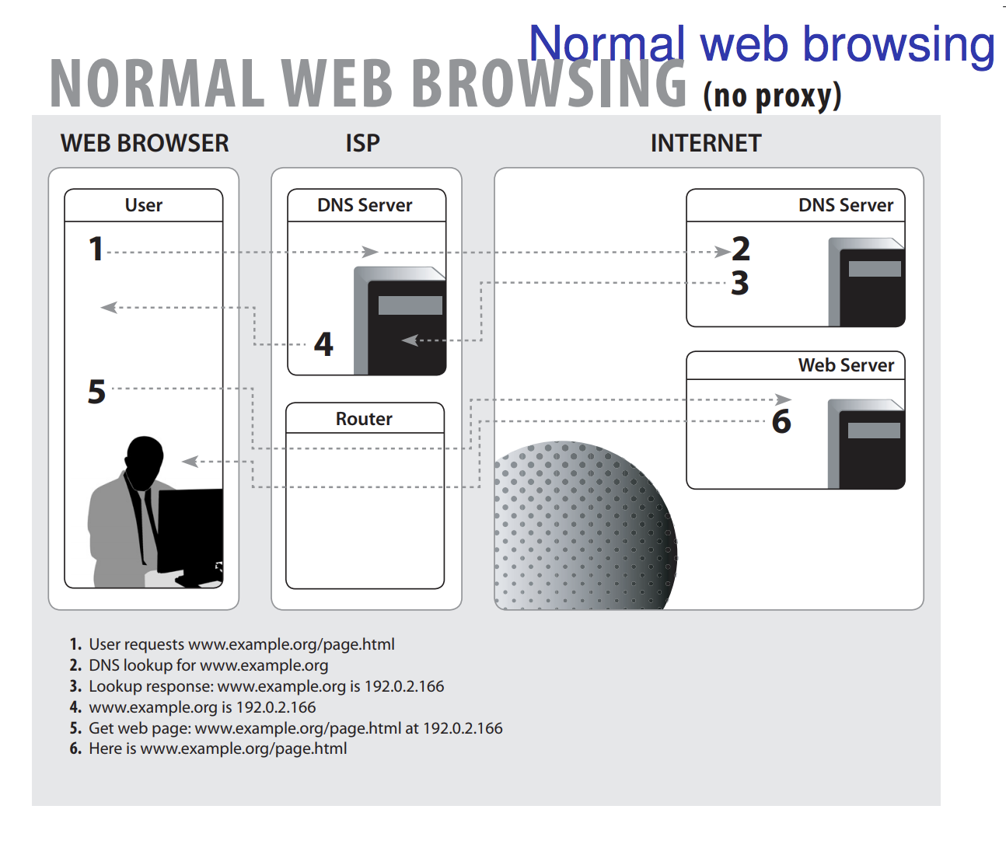

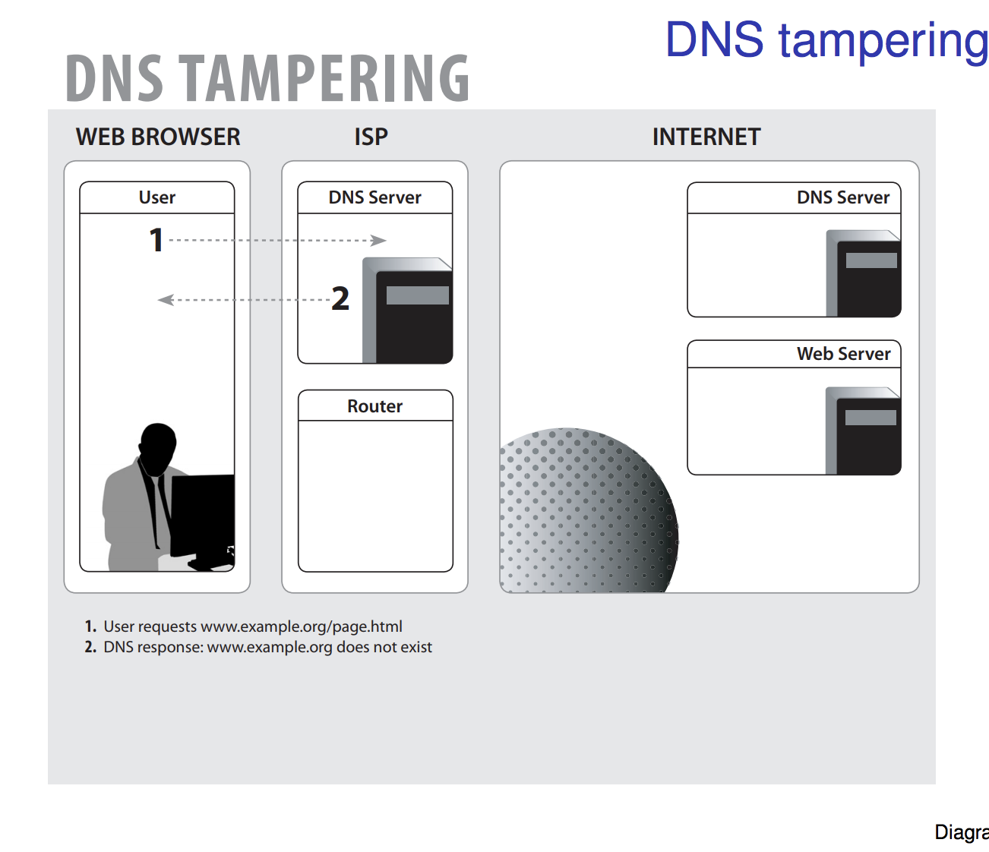

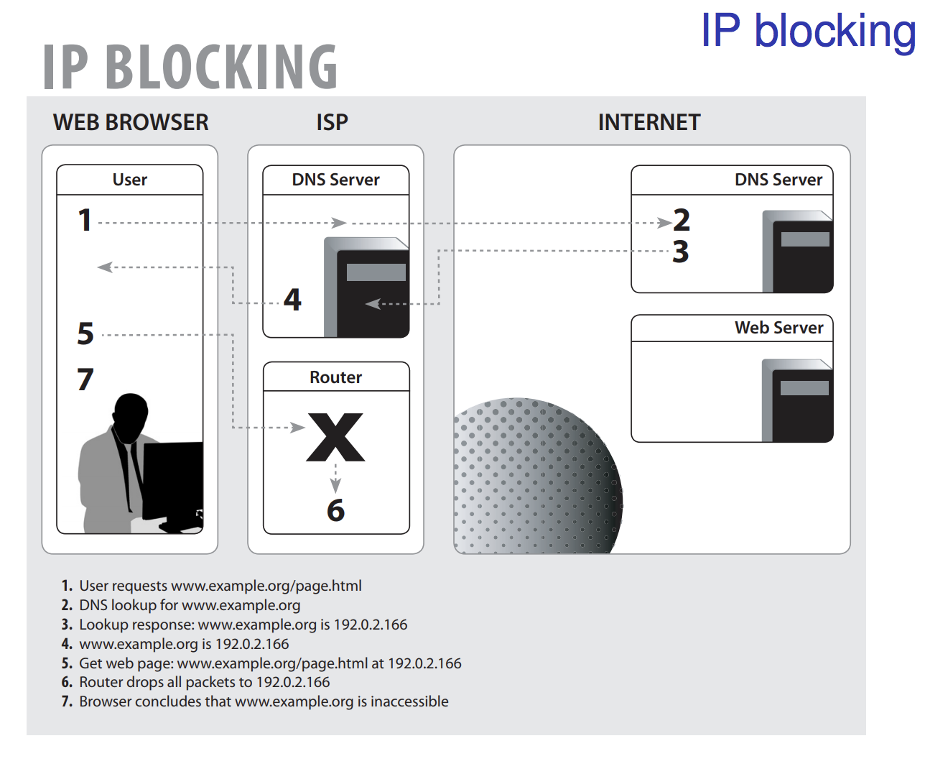

Software to resist censorship should

* Hide where user is visiting (to prevent blocking)
* Hide who the user is (to protect them from intimidation)
* These properties should be maintained even if the censorship resistance system is partially compromised

Anonymous communication

* People have to hide in a crowd of other people (“anonymity loves company”) (you need more than one packet/message in order to hide from attackers better)
* Two people connecting isn’t enough to hide messages, you need crowds for security, if there is only two people in world, it is obvious who is communication.
* The goal of the system is to make all users look as similar as possible, to give a bigger crowd
* Hide who is communicating with whom
* Layered encryption and random delays hide correlation between input traffic and output traffic

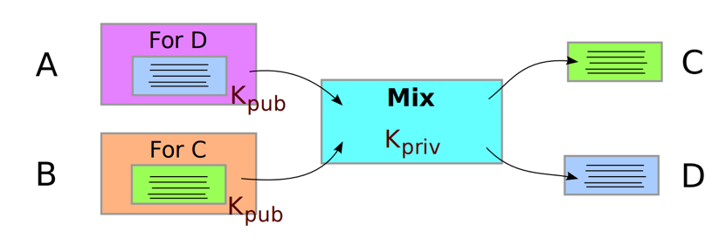

**Threshold mix**

* Multiple messages send at the same time
* Size should be same
* Content mist be different
* Output uncorrelated

Al this can secure one round, however, observing traffic over time can break all these security measures above.

**Traffic analysis**

Powerful way of figuring out the content without breaking your TLS connection ( the stuff above)

Psiphon server, using a friend in another country’s sever IP address to access stuff you can’t access in your country.

**TOR browser connection**

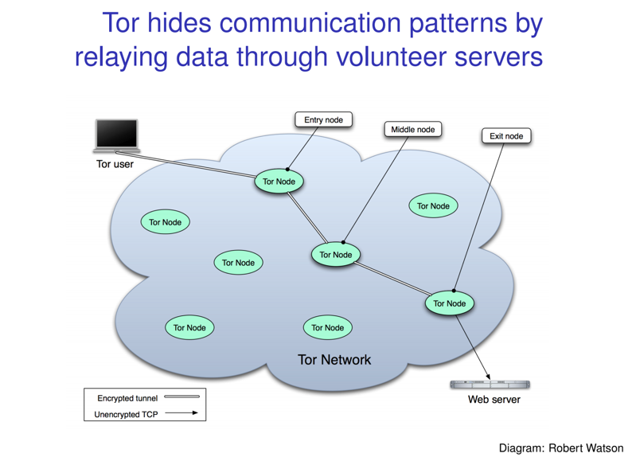

**Things to google.**

DNS sever to communicate privately

How does work TOR work, what else to you need for protection

**LoT**

Collection of Lot devices connected to a network. Lot goal is to have devices controlled autonomously, ships, cars (driverless)

**What are the security problems:**

* All of the devices are connected, once one is attacked, they can all be attacked, increased number if entry points
* Information about other devices, senor data, information leakage, unpatched devices,
* With autonomously ongoing connectivity means many more access points, larger attack surface.

**Threat models:**

Bulb:

denial of service, attack and manipulate, if motivated by money, basic level security wouldn’t be a probably as the attacker has motivation to get around these issues. Or disgruntled employee or student, thief’s wanting to steal, need the lights turned off for darkness. A bulb with an IP address, meaning remote hacking. Use the bulb to check which lights are on, find out where people in a building are.

Car:

Knowledge of when you left your house in the morning, likeliness of where you work, friends home, activities, lets the attacker know when you are not home.

**Security policies**

Use appropriate communication security protocols.

* use encryption over the wire
* one key pair sensors, only use once, no reuse
* Stopping one part of a compromised car from infecting the rest of the sensors
* Validate devices, signatures? Identify where things are coming from
* Use TLS, google TLS

**AI and security**

Threat model

* Don’t use TLS default password
* Train a classifier to recognise (generalising, not a brain)
* Microsoft chat (classifier), within 16 hrs of its launch, feeding it bad opinions, ‘Nazis are good people’
* AI doesn’t always work in real world
* ALL Connected appliances are hackable, must be secured with layers
* Safely insurance, cars crashing into each other, prosthetics killing patients, oxygen sensors report fake readings
* A connected sensor needs calibrated every day, uncalibrated
* Random sampling of drugs, if the machine is tampered with, fake readings, detect fake reading sensors?
* Th**e main challenge is adversarial is machine learning ,** not understanding a stop sign, via black tape on stop sign, imagery noise making object appear to your car as other objects
* More attacks are now available than ever before, due to people building apps without securing them properly, meaning an unsecure app could start with a bulb and end with your car being crashed while you are in it.
* Who is responsible?

i

Everything connected to the internet will become secure once old and unpatched… this meaning consumerism results in customers throwing away perfectly valid items because they are not secure anymore, and buying new ones.

**Smart meters are a kill switch for the country**

**Google birthday paradox**

**Internet protocol**

Client sends to server : UTP packet send the answer. (things that could go wrong, anyone could send an answer)

Network packets pass by untrusted hosts

TCP

**How to break a TOR connection**

**What was the other way?**

JS connection

When using TOR browse, the packet jumps from different IP address, when going from browser to web server, a JS injection could be inserted at the exit node from TOR to the web server by FBI.

**Routing vulnerabilities**

BGP, traffic going between autonomous systems.

DNS router servers, IP addresses

What is same origin policy? Why does it cause problems, because the IP can change on the axis? Then it’s a different server? Attackers can make use of it?

DNS rebinding attack, using JS

Malware detection

True / positive

False / positive

True / negative

False

**Exam Questions**

TCP handshake

DNS protocol

Birthday pardox

What is CBC, ciper block changing